
TEMPLATE FOR AUTHORS 2026

1.- First Page Information
Title in Spanish
(Suggested length: 100 characters including spaces)
Abstract
(Maximum length: 500 characters including spaces)
Keywords
(5 keywords written in lowercase and separated by commas)
Title in English
(Suggested length: 100 characters including spaces)
Abstract
(Abstract in English, maximum length: 500 characters including spaces)
Keywords:
(5 keywords in English, written in lowercase and separated by commas)
Author Profile
(Professional profile with a maximum length of 60 words. Follow the format shown below)
Name Surname, main professional activity. Current place of work or study and position held. Affiliation with institutions, projects, or collectives considered relevant.
Email address (use institutional email if available): example@usfq.edu.ec
Academic degrees listed as follows:
Degree obtained, name of the university or institution granting the degree, country of the institution.
Example:
Mijail Mitrovic, art critic. Professor at the Faculty of Art and Design, Pontifical Catholic University of Peru. Email: m.mitrovic@pucp.edu.pe
- PhD in Anthropology, Pontifical Catholic University of Peru.
Author ORCID iD
(Each author must have an account created at https://orcid.org/ and include their ORCID iD in the submission)

2.- Formatting Within the Text
In-text citations
post(s) follows APA style (7th edition). In-text citations must comply with the author-date system, including the surname and year (López, 2018). For direct quotations, include the page number (López, 2018, p. 15).
Example of in-text citations:
For this reason, Indigenous aesthetic-material practices also imply an understanding of territorial and communal perspectives that are often omitted by the art world; “in these ontologies, territories are vital space-times of interrelation with the natural world” (Escobar, 2014, p. 59).
Long quotations
Long quotations (40 words or more) should be included without quotation marks and with a left indentation of 1.27 cm (0.5 inches). The final period is placed before the author’s citation.
The aura causes the artistic object to break with homogeneity and become unique, something that cannot be achieved through mechanical and artificial reproduction of works:
The removal of the object from its shell, the destruction of the aura, is the mark of a perception whose “sense for the homogeneous in the world” has grown so much that it becomes capable, through reproduction, of finding homogeneity even in that which is unique. Thus, what manifests in the field of the visible corresponds to what, in the field of theory, appears as an increase in the importance of statistics. The orientation of reality toward the masses and of the masses toward it is a process with unlimited scope, both for thinking and for perception. (Benjamin, 2003, p. 48)
Captions for images, graphs, or tables
Each image or table included in the text must be properly identified following the uniform post(s) system: figure number, title of the work/table or image description, author or owner of the image, year of creation.
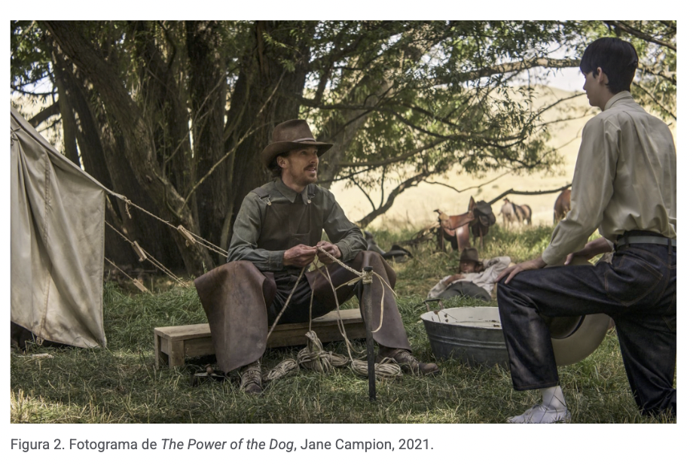
Each figure must be referenced within the text, including the figure number in parentheses (Figure 1) along with the corresponding mention.

3. Reference List
post(s) follows APA style (7th edition). The reference list, included at the end of the manuscript, must follow the appropriate format for each case. The basic structure is: Surname, Name. (Year). Title in italics. Publisher/Source. All cited sources must be listed.

Ejemplo:
Butler, Judith. (1998). Actos performativos y constitución del género: un ensayo sobre
fenomenología y teoría feminista. Debate feminista.

4. General Considerations
Funding
Any manuscript that has received external funding from academic institutions, public or private funds, or any other source must include this information at the beginning of the manuscript.
Example:
This project was funded by the Mellon Artist and Practitioner Fellowship at the Yale Center for the Study of Race, Indigeneity, and Transnational Migration.
Images
All images included in the manuscript must be submitted through the OJS system as separate files in PNG or JPG format at the highest quality (minimum 300 dpi, 600 dpi recommended).
For any questions regarding formatting, please contact: posts@usfq.edu.ec

